**Project title**

**UNEARTHING THE ENVIRONMENTAL IMPACT OF HUMAN ACTIVITY: A GLOBAL CO2 EMISSION ANALYSIS**

**BY**

**TEAM LEAD - N. RAJASREE PRIYADHARSINI**

**TEAM MEMBER 1 - G. KANAGALAKSHMI**

**TEAM MEMBER 2 - S. SNEKA**

**TEAM MEMBER 3 - S. NIVETHA**

**TEAM MEMBER 4 - S. KAVITHA**

1. **INTRODUCTION**

**1.1 Overview:**

**Global warming is one of the biggest challenges currently being faced by the human race, although correlation is not causation, a likely cause of global warming is due to increased atmospheric carbon dioxide from Human activities.**

**Co2 Emissions refers to the carbon dioxide emitted throughout the world. For this analysis we will be focusing on Co2 emissions and it's an effect on the world we live in as well as some key factors and stats that may play a role in the emission of co2 Fossil fuel use in the primary source of Co2.The data throws light onto how much Fossil fuels are burnt, per year per nation, which amounts to an increase in CO2 every year.**

**This will help researchers and environment experts to predict global warming. So countries should set a goal to decrease this amount yearly.**

**Analysing Global Co2 Emission across countries from 1975 to 2020. This data set contains a record of co2 Emission by each country and Region of Earth, here we are going to analyse and visualize Country wise, Region wise and overall Co2 Emission on Earth.**

**1.2 Purpose:**

**The carbon in Co2 can be used to produce fuels that are in use today, including methane, methanol, gasoline and aviation fuels. The process involves using the co2 in combination with hydrogen, which is highly energy- intensive to produce, and result in a carbon containing fuel that is easier to handle and use than pure hydrogen.**

**Low-Carbon hydrogen can be produced from Fossil fuels when combined with CCS, or through electrolysis of water using low- carbon electricity.**

**Greenhouse gas emissions from industry primarily come from burning Fossil fuels for energy, as well as greenhouse gas emissions from certain chemical reactions necessary to produce goods from raw materials. If emissions from electricity use are allocated to the industrial end-use sector, industrial activities account for a much larger share of U.S. greenhouse gas emissions.**

1. **PROBLEM DEFINITION AND DESIGN THINKING**
   1. **Empathy Map:**

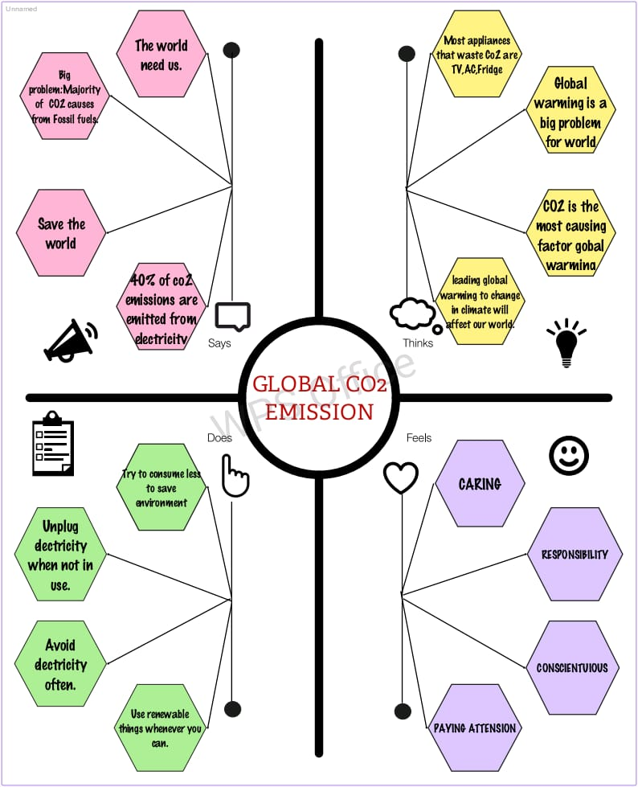

**2.2 Ideation and Brainstorming Map:**

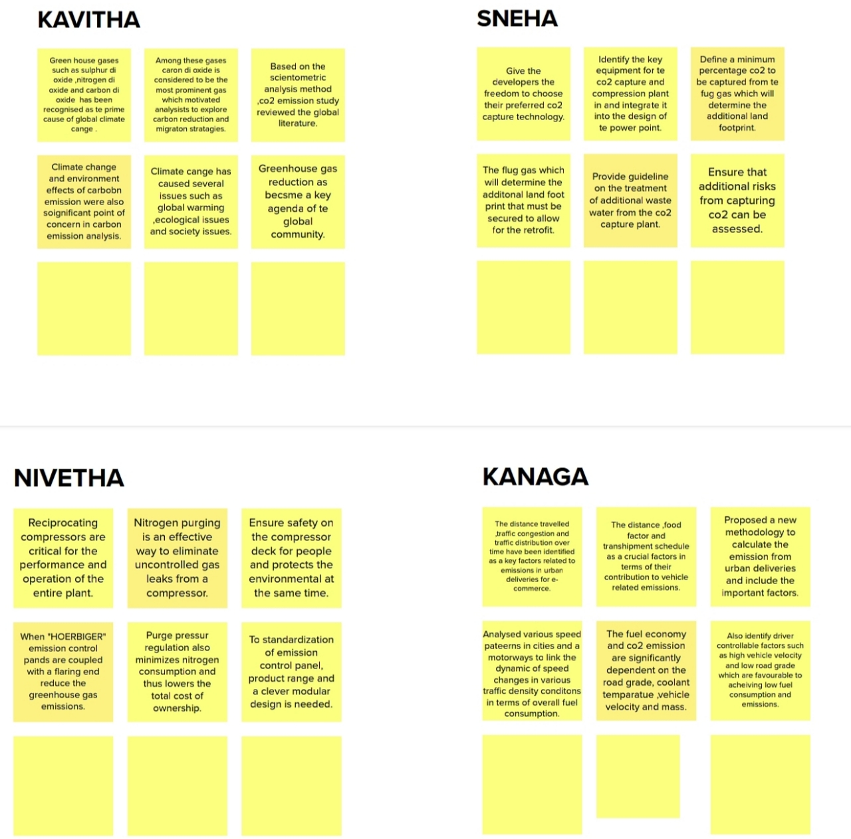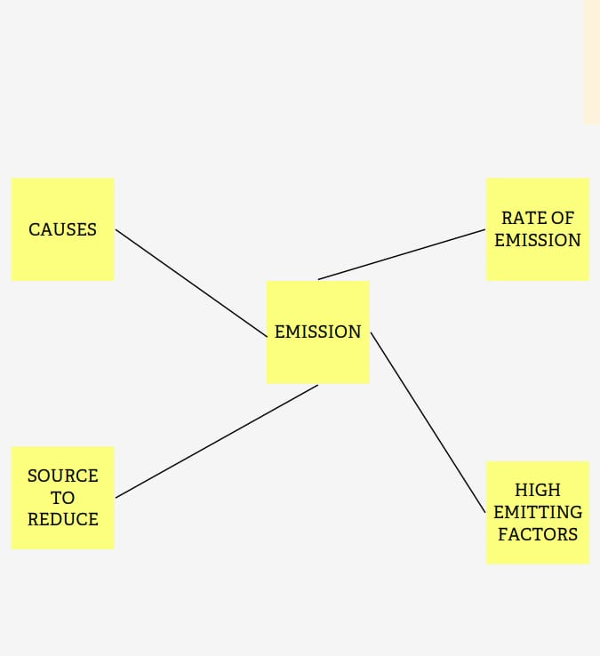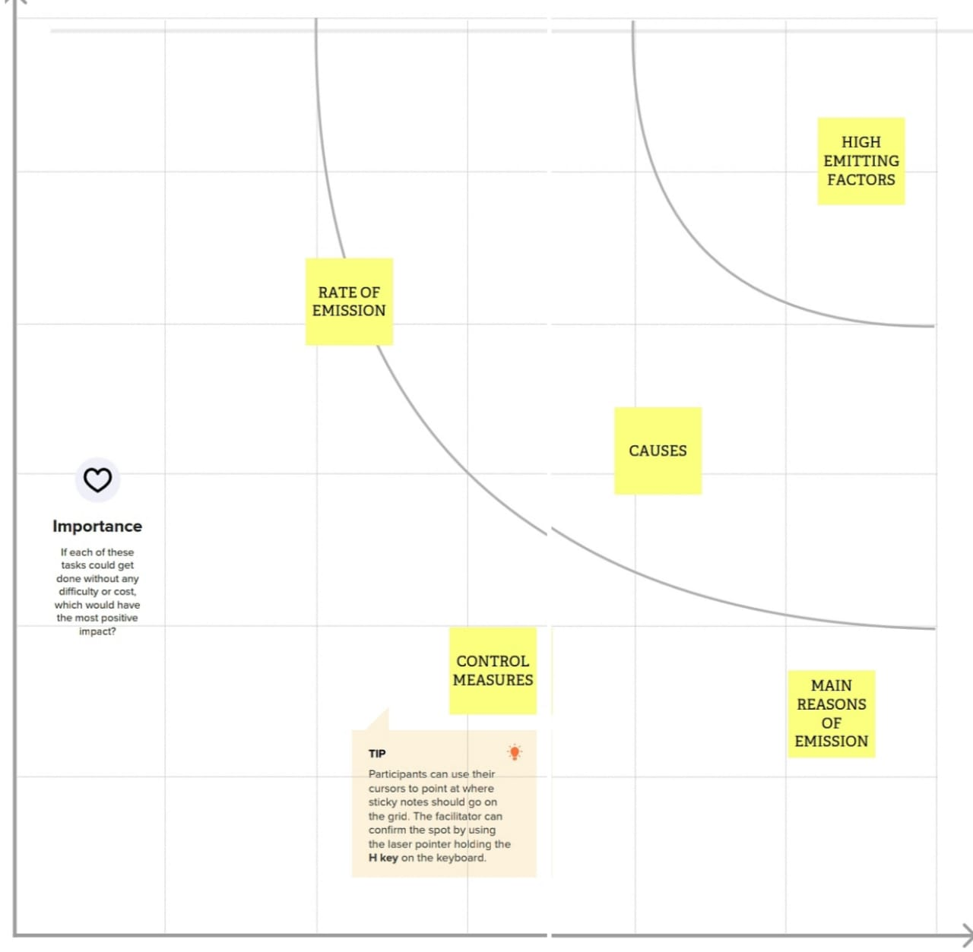

1. **RESULT**

**3.1 Data Model:**

|  |  |
| --- | --- |
| **OBJECT MODEL** | **FIELD IN THE OBJECTS** |
| **Object 1:**  **Empathy map Brainstorm and Ideation** | **Data Type:**  **MURAL** |
| **Object 2:**  **Database** | **Data Type:**  **MY SQL, DATA TYPES** |
| **Object 3:**  **Work Sheet** | **Data Types:**  **TABLEAU PUBLIC DATA TYPES** |

**3.2 Activities and Screenshots:**

**A dashboard is a graphical user interface (GUI) that displays information and data in an organized, easy-to-read format. Dashboards are often used to provide real time monitoring and analysis of data, and are typically designed for a specific purpose or use case. Dashboard can be used in a variety of settings, such as business, finance, manufacturing, healthcare, and many other industries. They can be used to track key performance indicators (KPIs), monitor performance metrics, and display data in the form of charts, graphs, and tables.**

**Dashboard 1:**

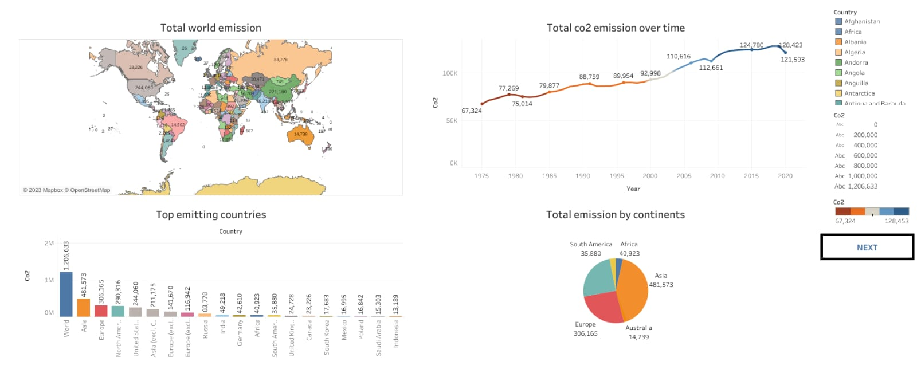

**Dashboard 2:**

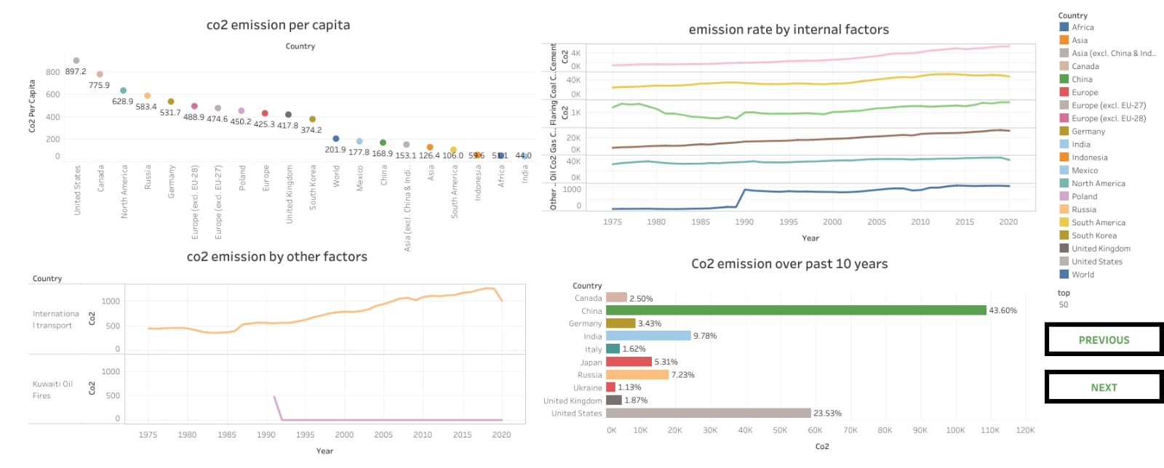

**Dashboard 3:**

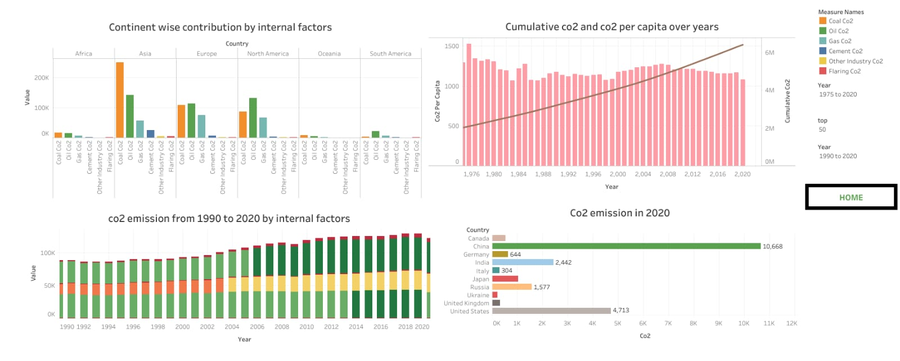

**STORY**

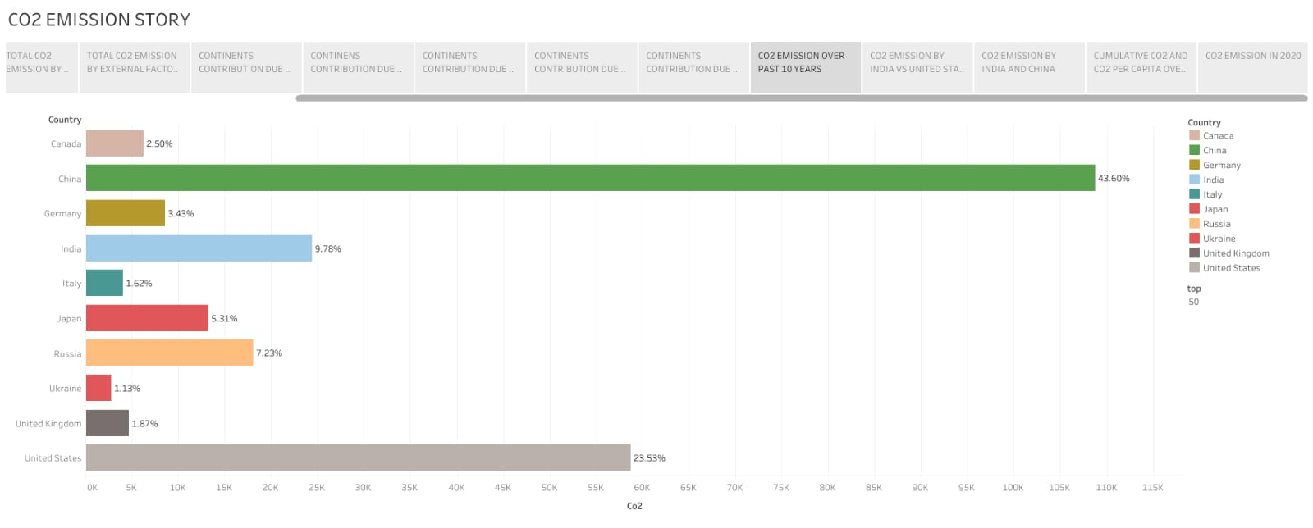

1. **TRIALHEAD PROFILE PUBLIC URL**

**TEAM LEAD : https://trailblazer.me/id/priyadharsini2228**

**TEAM MEMBER 1 : https://trailblazer.me/id/kanaga123**

**TEAM MEMBER 2 : https://trailblazer.me/id/ssneka9**

**TEAM MEMBER 3 : http://trailblazer.me/id/nselvaraj22**

**TEAM MEMBER 4 : https://trailblazer.me/id/kavi1992**

1. **ADVANTAGES**

* **Carbon capture and storage is one of the most efficient methods of extracting carbon emissions permanently from the environment.**
* **The numerous advantage of CCS includes economic, social and environmental, and a massive impact on a global and local scale.**
* **Carbon capture can increase the power generated with carbon- dioxide based steam cycle. In this process, carbon dioxide is pressured through a super critical fluid, which could transfer heat more effectively and requires less energy to compress steam.**
* **Geologically stored carbon dioxide might be utilized to retrieve geothermal heat from the area injected which results in the generation of sustainable geothermal energy.**
* **Carbon dioxide captured with carbon capture can also be utilized in the manufacturing of polymers and chemicals such as polyurethanes.**

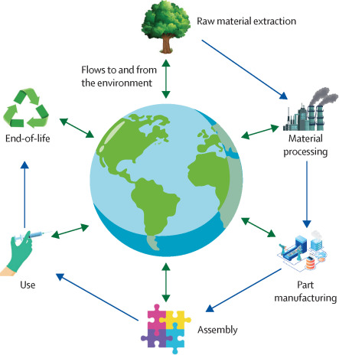

* 1. **DISADVANTAGES**

1. **Heat waves**
2. **Pollution**
3. **Insect plagues**
4. **Hurricane, Fires and Natural Disaster**
5. **APPLICATIONS**

* **Carbon dioxide is used as a refrigerant, in fire extinguishers for inflating life rafts and life jacket, blasting coal, foaming rubber and Plastic, promoting the growth of plants in greenhouses immobilizing animals before slaughter, and in carbonated beverage.**
* **Ignited magnesium continuous to burn in carbon dioxide, but the gas does not support the combustion of most materials. Prolonged exposure of humans to concentration of 5 percent carbon dioxide may cause unconsciousness and death.**

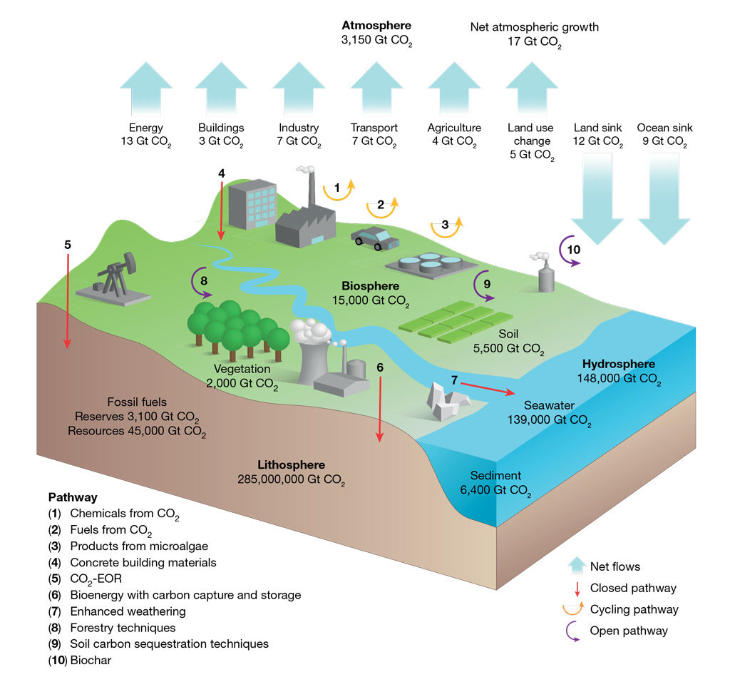

1. **CONCLUSION**

**In this project, we review the global co2 emissions. This chapter opens with a review and synthetic of our conclusion on the expected effect on the co2 emissions and their works through these machanism.by detecting this we get a conclusion about the aspect of improvement related to the country.**

1. **FUTURE SCOPE**

**Scope 1- scope 1 covers emissions from sources that an organization owns or controlled directly.**

**Scope 2- scope 2 are emissions that a company causes indirectly when the energy it purchases and uses is produced.**

**Scope 3- scope 3 encompasses emissions that are not produced by the company itself, and not the result of activities from assets owned or controlled by them, but by those that it's indirectly responsible for, up and down it's a value chain.**